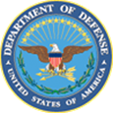

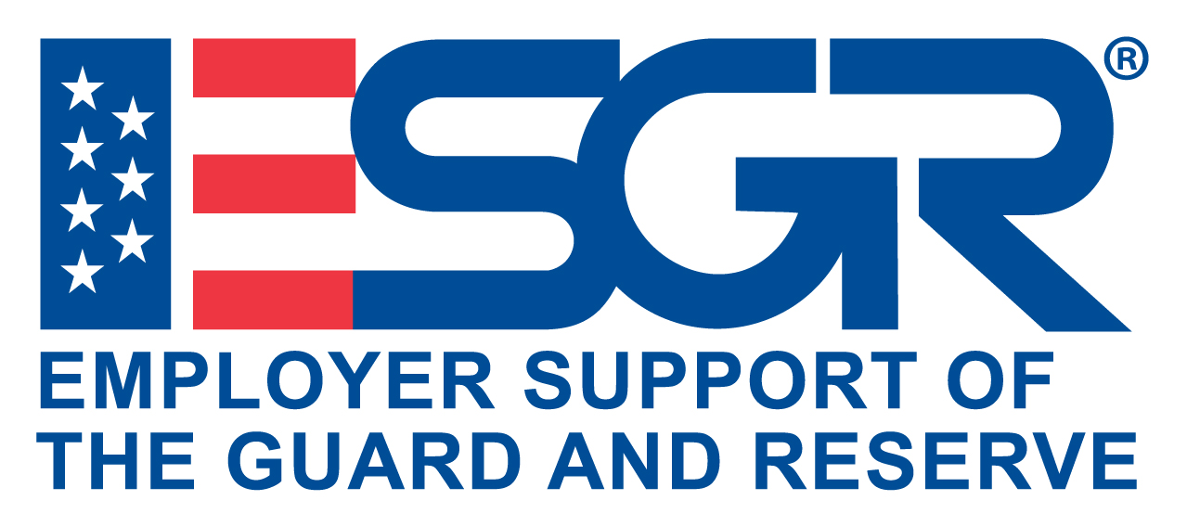

Invite your CIVILIAN Employer

Gowen Field BOSSLIFT

Boise, IDAHO

August 8-9, 2019

Employers can be part of the action and see first-hand what the National Guard and Reserves do when they are on duty.

* The Gowen Field Bosslift is for Employers in the local Treasure Valley area (Boise, Kuna, Meridian, Nampa, Caldwell, Eagle, and Mountain Home), Twin Falls, and Eastern Idaho.

**Event Highlights:**

* **Engage targets in weapons simulators and operate various military equipment**
* **Participate in a Blackhawk helicopter orientation flight**
* **Be part of the military for two days to better understand how “We All Serve”**
* **Gain insight about what Idaho’s citizen-soldiers do in a training environment**
* **Hear about Idaho’s National Guard and Reserve mission and assets**
* **Show your support for Idaho’s citizen warriors**

**Come be a “Boss in Boots” for two days!**

Participation is by “invitation only” from the Department of Defense Idaho ESGR committee. Nominations are accepted on a first-come, first-served basis. Priority is given to employers of Guard and Reservists, community leaders of civic organizations, company owners and managers.

**Attendance is limited to 120 and the selection process begins with your early application.**

Complete a Nomination Form and mail or scan/email to the Idaho ESGR Bosslift Director:

**Linda Eisele, 3203 Seminole Dr., Nampa, ID 83686**

**Email:** [**idahobosslift@outlook.com**](mailto:idahobosslift@outlook.com)

For more information, please contact Linda Eisele at (208) 890-2321 or Eddie Clemons at (208) 272-3346